1. Checkboxes in my decks tab still launch example decklist (only the words should do this)
2. Appears to change the status of the requester to ‘provider’ upon a start of a session
3. Timer appears instantly instead of after a X(.9)-5min delay
4. Audio chat is still not live (still just a text entry method)
5. Timers are out of sync
   1. 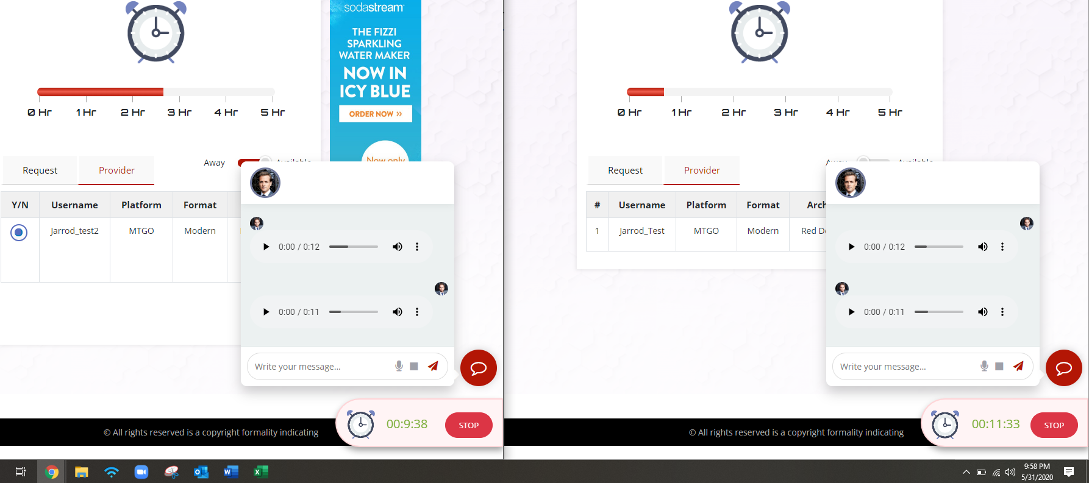
6. No warning message about the session ending soon at the 5 min remaining mark. (same point at which the timer should appear)
7. Time transferred to the wrong user (it should transfer from requester[left] to provider[right])
8. All advertisements disabled, this purple box still appears.
   1. 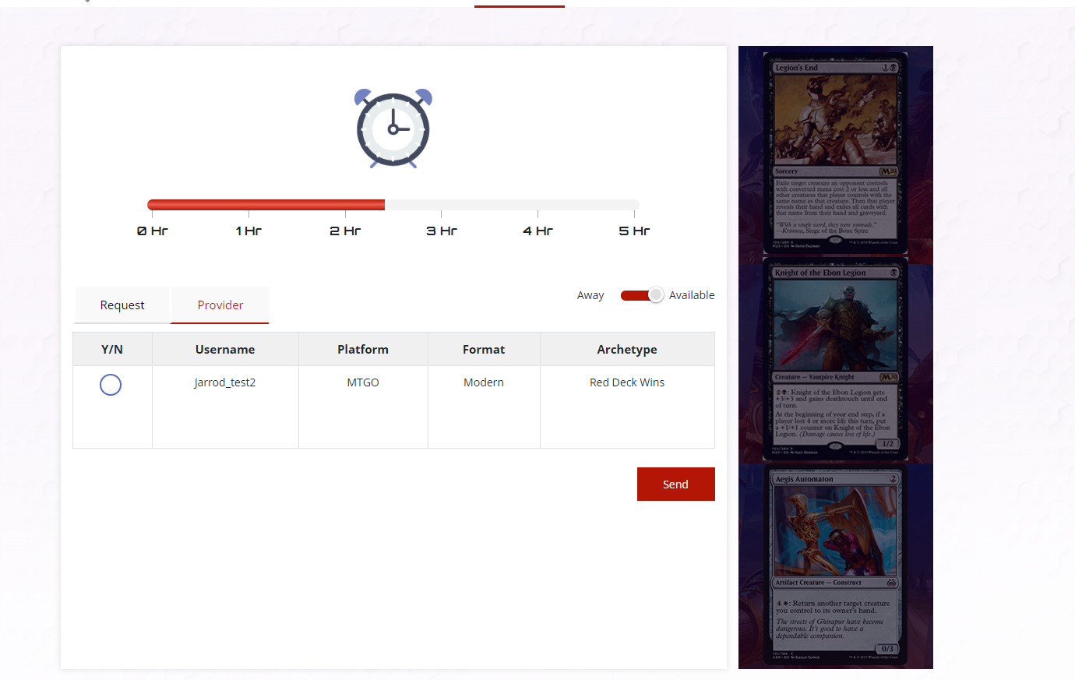
9. Deck Editor > Upload Popup > Enter button has no functionality
10. No quantity column in deck editor (should not list same card twice, but instead add to the quantity)
    1. 